**Stutter Support: Usage Description**

Stutter Support is an Android app for teenagers with stuttering, which uses the PocketSphinx speech recognition library for interactivity. Its purpose is to allow the user to practice his or her speech skills using interactive speech exercises and anxiety management techniques.

**Splash**

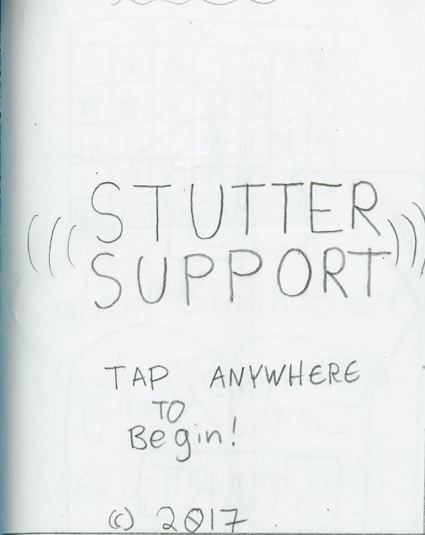

Use of the app begins with a splash screen to allow for smooth background loading of the app assets. This screen is also used to display copyright and credit information. Tapping anywhere on the screen displays the game’s main menu, which functions as a carousel.

**Menu**

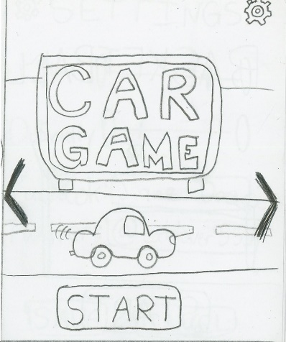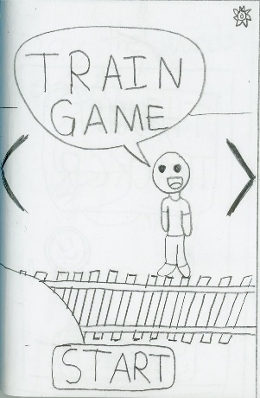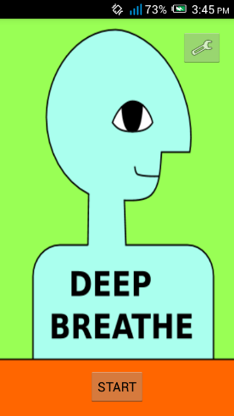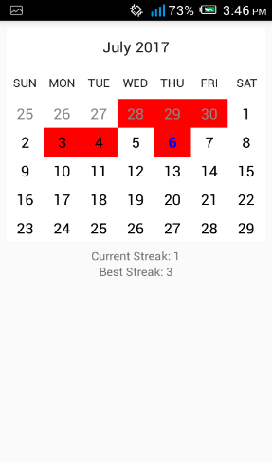

Dark arrows on the left and right sides of the screen indicate to the user that he can swipe left and right to navigate through the menu. Three features are accessible through this menu, through the ‘Start’ button at the bottom of the screen. Tapping the Start button loads the corresponding exercise or activity. Some activity titles shown here are temporary.

The fourth screen in the carousel menu contains a calendar indicating which days of the month the user has successfully completed at least one exercise, as well as statistics about his current and best ‘streak’ (days in which at least one exercise is completed). The purpose of this screen is to encourage repeat use of the app.

Consistent between all the screen is a wrench icon in the top right corner of the screen. Tapping this icon loads the corresponding Settings screen.

**Settings**

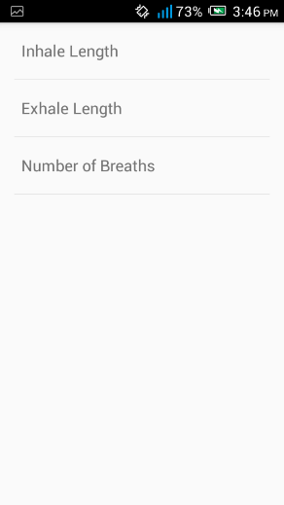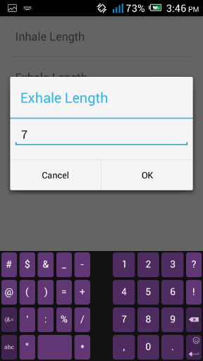

Stutter Support utilizes Android’s native persistent preferences framework for saving user preferences and generating settings screens. Each feature within Stutter Support has a corresponding settings file and configuration screen.

Within the settings screen for Deep Breathe, the user can adjust how long each breath should take, and the number of breaths she would like to do.

**Car Game**

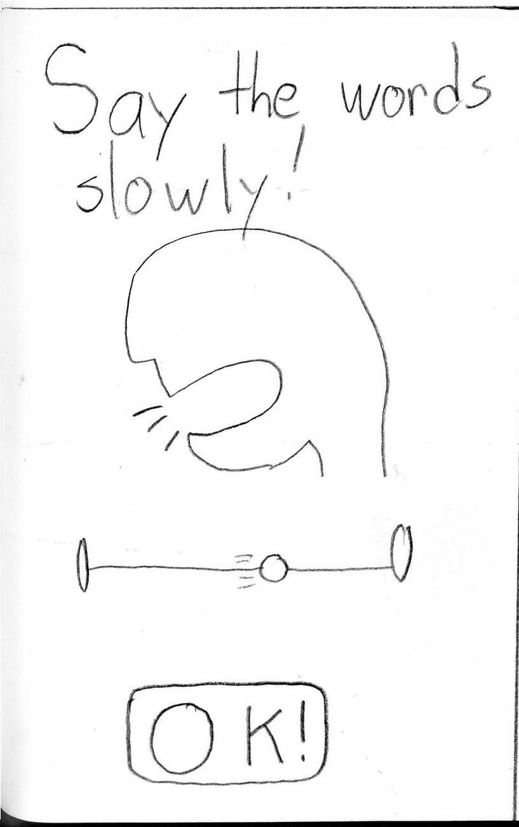

All speech exercises open with a demonstration of the skill required. In this case, a simple animation demonstrates that the goal of this exercise is to use prolonged speech to say words as they appear on the screen. Tapping the ‘OK’ button begins the exercise.

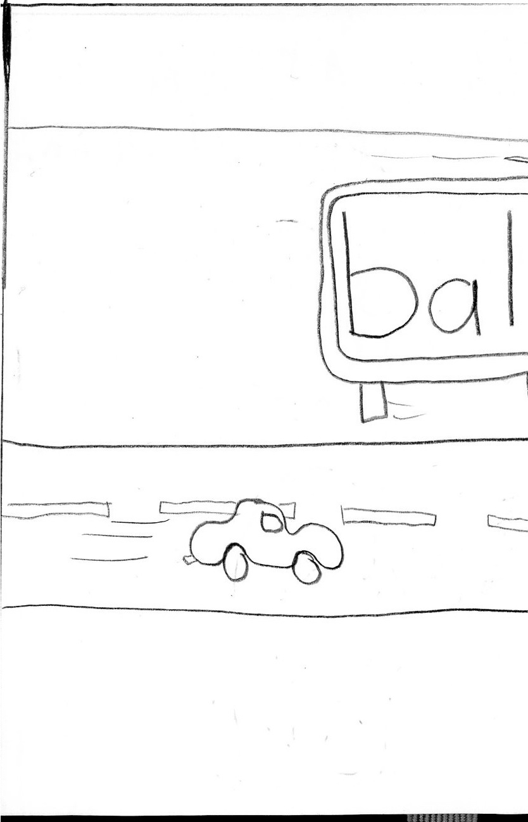

In this exercise, a car is shown driving down the road, and signs slowly roll past with words on them. The user must say the word for as long as it appears on the screen.

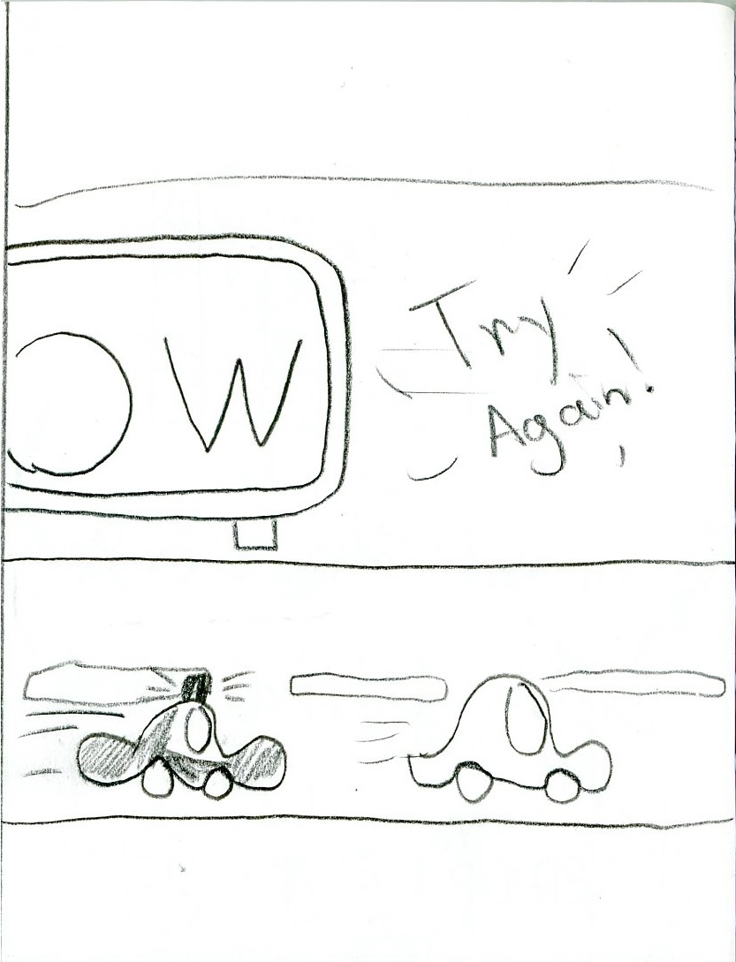

Should the user finish a word before the sign is out of sight, a police car will appear to warn the player for ‘speeding’, and encouragement to try again will appear on the upper portion of the screen. The exercise will then resume with the car moving and words scrolling by.

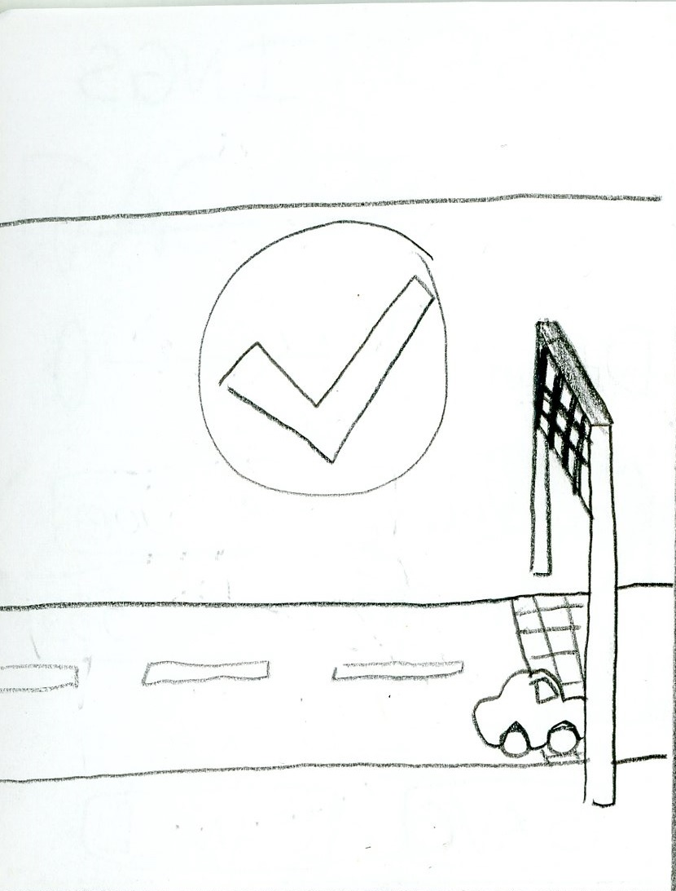

When the user has successfully prolonged enough words (as determined by the difficulty setting), the car will arrive at a goal post and the activity will end.

**Train Game**

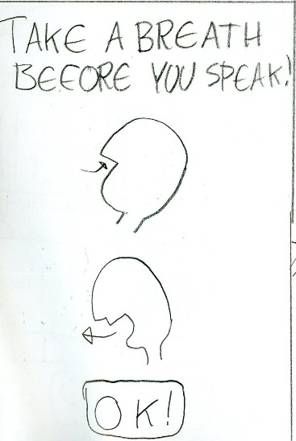

The goal of this exercise is to pause to take a break to breathe before speaking. An animated demonstration guides the user to use the forced break in the exercise to take a breath to prepare to speak.

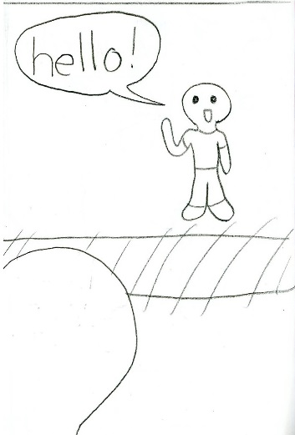

The exercise opens with two figures standing facing each other across train tracks (note: drawing is simplified for demonstration purposes. App will display figures standing safe distances from the train tracks). The opposite figure will display a speech prompt (nature of prompt will depend on the difficulty setting).

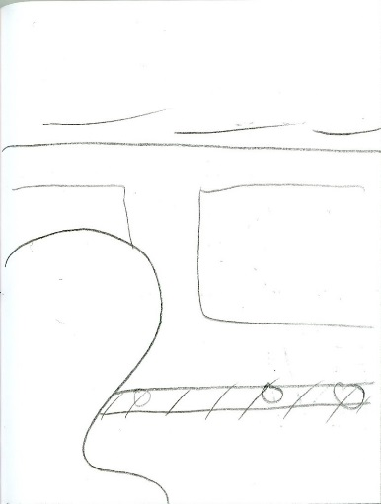

A train will then be shown to be rushing by the figure representing the user. The user should take this forced break in the conversation to breathe before speaking.

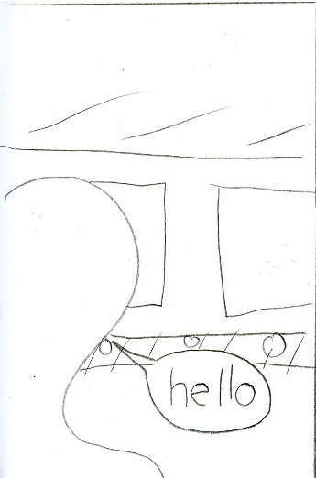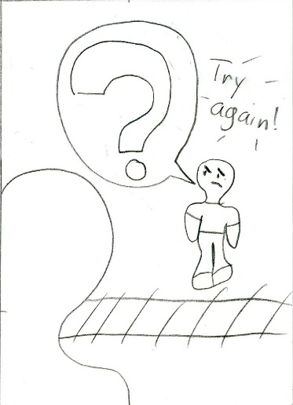

If the user speaks while the train is going by, the app will register the speech as rushed. The opposite figure will not have heard what was said, and appear confused. Encouragement to try again will appear in the upper portion of the screen.

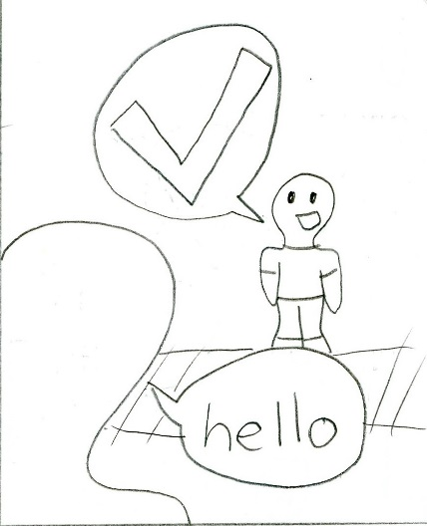

If the user waits until the train has passed, and then begins speech, the opposite figure is shown as understanding the user, and the exercise is considered a success. The exercise is completed when enough prompts have been answered successfully in this manner.

**Deep Breathe**

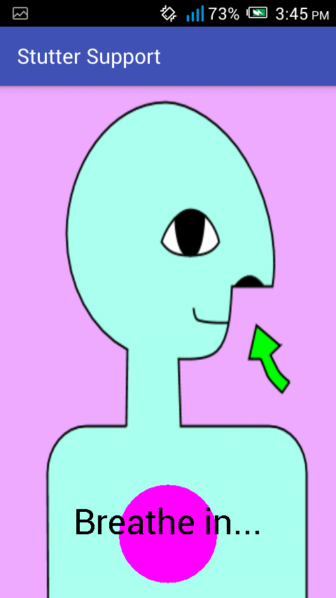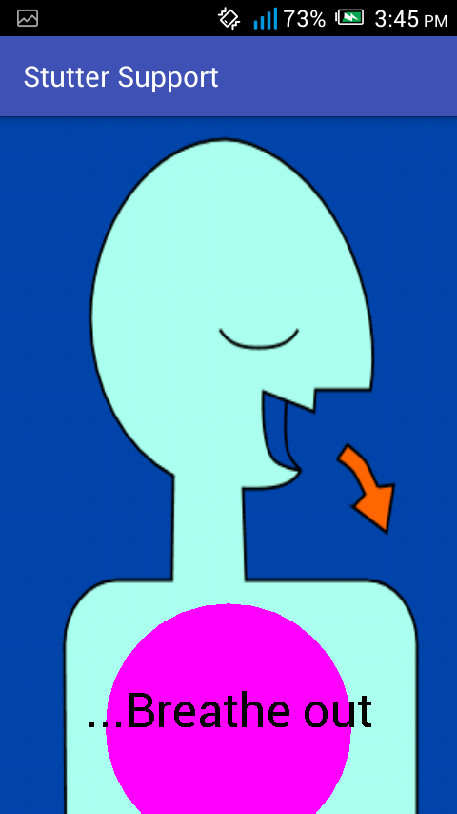

The purpose of this activity is to establish calm in the user through deep breathing. The activity defaults to using the popular ‘7-11’ form of deep breathing, showing a figure breathing in for 7 counts and out for 11 counts. The length of each breath can be adjusted in the settings. The circle in the figure’s chest expands and contracts along with instructions displayed inside, so that the user can easily breathe along with the demonstration. The demonstration ends after the number of breaths defined in the settings, which defaults to 5.

**Encouragement**

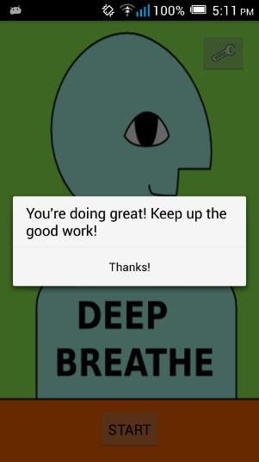

After successfully completing an exercise, some words of encouragement will appear on the screen. Tapping ‘Thanks!’ will return the user to the carousel menu.

**Social Media Integration**

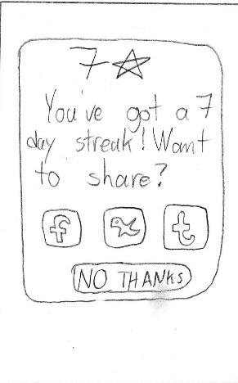

When important milestones, such as one week or one month of continuous app use, are met, the option to post about the achievement to a social media network is presented to the user. Further actions are handled by Android’s native message passing framework, meaning that the user can easily send the app’s message to any social network or messaging system installed on the phone.

**Future Versions**

**Bubbles**

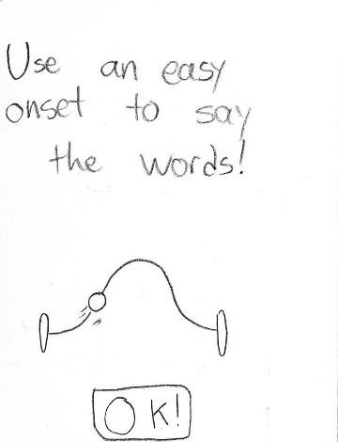

The goal of this exercise is to use the ‘easy onset’ skill to say words gently. This reduces tension within the vocal muscles, allowing for more fluent speech. An animation demonstration shows the volume level of the word over time. Tapping the ‘OK’ button begins the exercise.

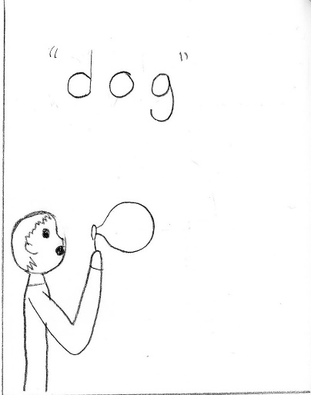

The exercise begins with a figure holding a bubble wand. As easy onset is used to say the word on the screen, the bubble inflates.

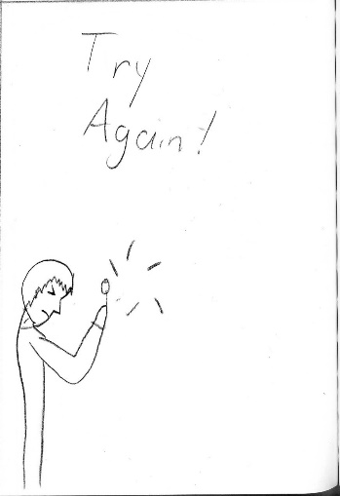

If the word is said too harshly, the bubble will pop, and encouragement to try again will appear in the upper portion of the screen. The exercise will then resume with another word.

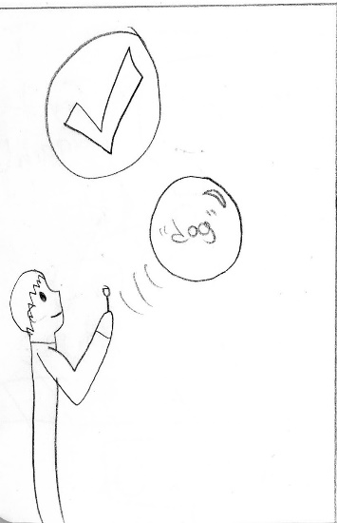

If the word is said correctly, using easy onset, then the bubble will float away. After enough words are successfully said using easy onset (determined by the difficulty setting), the exercise will be considered successfully completed.

**Basketball**

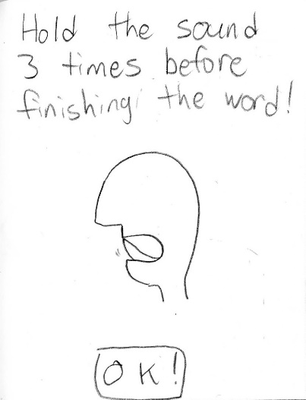

The goal of this exercise is to practice controlled stuttering. An animated demonstration shows a sound being repeated by an open mouth. Tapping the ‘OK’ button begins the exercise.

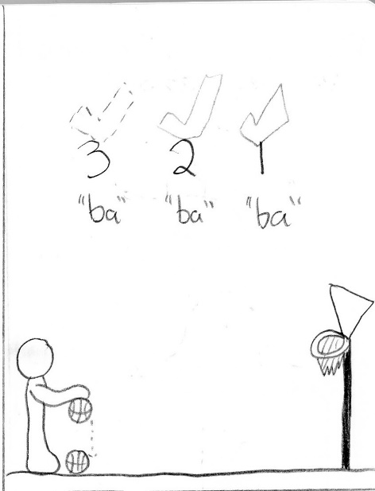

The exercise opens with a figure bouncing a basketball on the ground. The first sound of a word is repeated with each bounce of the ball. The actions are counted down on the upper portion of the screen.

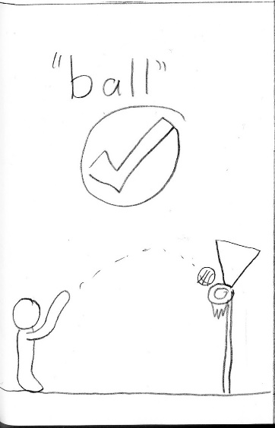

Once the ball has bounced three times, the word is said smoothly, and the ball is shown being thrown into the basketball hoop. The exercise is considered completely when enough words are successfully finished in this way.

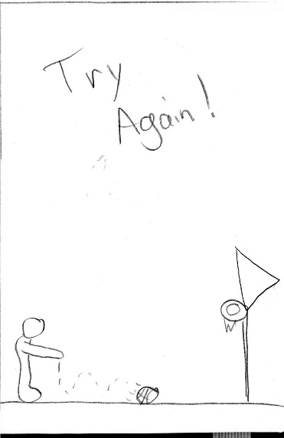

If at any time a sound is stumbled on, or missed, the figure is shown losing control of the ball, and encouragement to try again is shown. The exercise then resumes with a new sound.

**Script Reading**

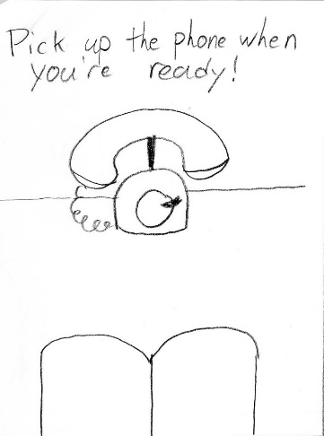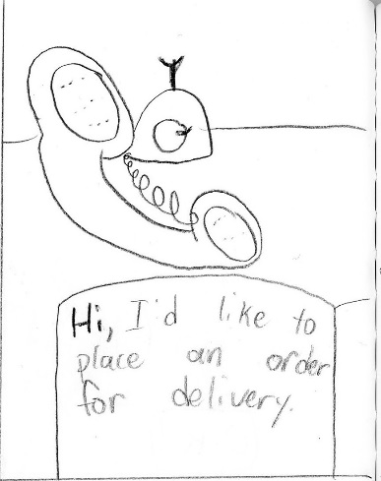

The purpose of this activity is to practice fluency and lower stress about common speaking situations, by reciting practice scripts aloud in a low-stress environment. Tapping the phone begins the script, which is highlighted as the user speaks the words.

**Thought Tracker**

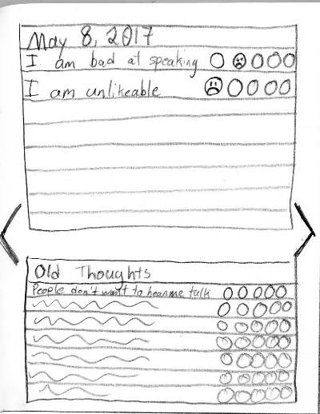

This tool is used to track negative thoughts related to speaking and stuttering, for tracking and better identification within cognitive-behavioural therapy of distorted or catastrophized thinking. Thoughts can be entered with the system keyboard, and a mood rating can be associated with them. Previously entered thoughts can be easily re-added to the current day by selecting them from the ‘Old Thoughts’ list.

Black arrows on the left and right of the screen indicate to the user that swiping is possible. Swiping from the left on the screen brings up old tracker entries for reference. Swiping from the right on the screen opens the summary view.

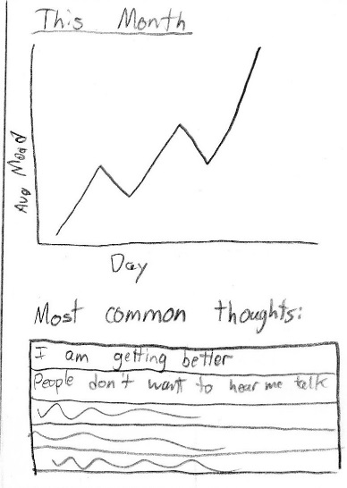

This view displays a graph of the average mood of each day of the last month, as well as the thoughts most commonly logged into the app. Swiping from the left returns to the current date.